ABOUT FRIEND OF SINGA 2015

Introduced in 1990, the Friend of Singa (FOS) is into its 25th year. FOS aims to empower students to lead their schools in a 6-month kindness campaign. It also complements MOE’s and the schools’ efforts in their Character and Citizenship Education and Values-In-Action programmes.
FOS 2015 is open to all students in primary schools and secondary schools (including international and SPED schools). Building on the notion of collective kindness, the theme for FOS’s Silver Jubilee is “A Nation of Kindness Starts with One.”

Participating schools are invited to nominate up to eight students for this award. These students will be honoured as Friend of Singa Ambassadors upon completing a kindness project together. The Singapore Kindness Movement (SKM) hopes that by giving the students such recognition, it will encourage their peers to emulate their fine example.

Please log on to kindness.sg or kindness.sg/Kindsville/friend-of-singa-2015-silver-jubilee/ to register. The deadline for registration is 30 January 2015, Friday 6pm.

*To help kick start these projects, SKM will help fund up to $150 per project.
A timeline of the process of FOS 2015:
30 January (Fri) 6pm
Select up to 8 students for FOS Programme
6, 9-14 February

Teachers & Students to attend a half day workshop
25 March (Wed)
Project proposal submission

*Teachers are encouraged to submit earlier
SKM’s approval of project

(About 2 weeks after proposal submission)
April – August

Execute Kindness project & write report
25 August (Tue)

Mail out report

*Teachers are encouraged to submit earlier
28 August (Fri) 5.30pm

Project to reach SKM

13 November (Fri)

Attend the FOS Award Ceremony & Exhibition

- WORKSHOP:
FOS 2015 workshops will be conducted by The Beanstalk Creative Actions Pte Ltd. Participants (students and teacher in-charge) will be equipped with design thinking skills for problem solving and project management.
Schools may indicate their preference for the date and session of the workshops. SKM will try its best to accommodate everyone, but kindly note that SKM reserves the final right to allocate the date and session for each participating school.
Workshop outline
8am (Session 1) or 1pm (Session 2)

- Introduction to Design Thinking tools
- Hands on group thinking
10.30am (Session 1) or 3.30pm (Session 2)

Teabreak
11am (Session 1) or 4pm(Session 2)

Ideation and prototyping the solution
- Setting visions & action plans
12pm (Session 1) or 5pm (Session 2)

End of workshop

The details of the workshop are as follows:
Venue: *SCAPE Treetop
2 Orchard Link, *SCAPE, Level 5 (The Treetop) Singapore 237978

Dates:
- Primary Schools & SPED
- 6, 10, 12 February 2015, Friday
- Secondary Schools & SPED
- 9, 11, 13 February 2015, Monday

Time slots:
- Session 1: 8am- 12pm, Schools to arrive at 7.30am
- Session 2: 1pm- 5pm, Schools to arrive at 12.30pm

Dress code: School uniform (PE shirts and shorts are advised)
- Girls wearing full school uniforms are advised to wear shorts inside

- KINDNESS PROJECTS:
After attending the workshop, the students must complete a group project related to the given theme in their schools. The theme for this year is “A Nation of Kindness Starts with One.” Only projects that create an impact within the school community will be considered. Projects related to the larger community such as beach clean-ups, visiting an old folks’ home and donations to a charity organisation will not be factored into the funding as it is considered Community Involvement Programme (CIP).
Projects’ content/messages should not be offensive or contain any racial, political or religious implications.
Students may consider:
- Highlighting the social graces that are found lacking and effecting positive change in schools
- Raising the awareness of the benefits of having a respectful school
- Celebrating or recognising the kindness of classmates or teachers
- Inspiring schoolmates and staff to practice kindness and graciousness in schools
- Creating an impact in the school to bring about a more positive behavioural change
- Creating awareness that the student’s immediate family plays a huge part in cultivating kind and gracious habits

Students need to submit a project proposal report (see Project Proposal Form attached) to SKM office by hand/ mail by 25 March, Wednesday 6pm. This is to ensure the projects are in line with the FOS objectives. Proposals may be submitted earlier.
Students and teachers will have up to 5 months to work on their projects. The final project report submission must reach SKM by 28 August 2014, Friday, 5.30pm.
Reports may be submitted earlier.
If submission is via post, it is recommended to mail out before 25 August 2015, Tuesday.

Some project ideas:
- Kindness competition — Organise respect-related competitions such as essay writing, poster designing, poem writing, comic creating, etc. Outstanding entries may be displayed around the school.

- Kindness collaboration — Teachers can design poster for students to colour; posters can be pasted around the school.

- Kindness Zone — Decorate a kindness zone along one of the corridors. When students or the staff passes by this zone, he/she will have to pass on the kindness to someone else. The FOS students may record a video to show these acts of kindness.

- Kindness Pledge Day / Month – Organise a day/ month of kindness. During this time, students, teachers and schools staff (which include janitors, canteen vendors, etc) exhibit and promote kindness and graciousness all around the school.

These are just some ideas to help you start the kindness projects in your school. You need not follow strictly to these ideas. We welcome creative and original ideas that address specific issues in the schools.

- SECRET AGENT MISSION

To commemorate the spirit of collective kindness, SKM will send a Secret Agent Mission kit to all participating schools every month for six months. Each mission kit will contain the relevant resources revolving around the secret mission.

This Secret Agent Mission aims to further engage all students in a fun and light-hearted manner. The FOS ambassadors would help to announce the secret mission to their schoolmates. Anyone within the school can participate in the secret mission (they need not be FOS ambassadors).

To participate, students or staff will need to upload pictures or write-ups of kind acts that relates to the mission that month and post it up onto the Facebook page stating their name and school. These initiatives can be executed both in and outside of school.

Appreciation tokens will be given out to outstanding initiatives which are showcased on the Facebook page

FOS Secret Agent page:
https://www.facebook.com/FOSsecretagentmission

You can visit SKM’s Facebook page for some inspiration at: https://www.facebook.com/kindness.sg.
- EVALUATION & AWARD SYSTEM
After attending the workshops and successfully implementing the kindness projects in their schools, FOS nominated students will be awarded a certificate and a FOS pin at the awards ceremony.
To commemorate the Silver Jubilee, SKM will do away with award system based on merit. Instead, schools will be recognized for sustained participation in FOS:
- 1st year
- 3 years
- 5 years
- 10 years and above

Evaluation of the projects (new project criteria outline)
Although FOS is no longer a competition based on merit, the projects executed should still make an impact and significant difference on graciousness within your schools. The project should reach out to both students and staff. Schools with outstanding projects will be highlighted during the awards ceremony.
Your project will be evaluated based on the 10 criteria listed below. There are 5 compulsory criteria, in asterisks, which your project must fulfil. The other 5 criteria are optional, but highly encouraged as they will help guide your project towards an impactful one.
- Relevance to the theme*
- Please state how the project is in line with the theme
- Impact of FOS project*
- Pre and post-surveys to track behavioural change.
- Survey results to be collated into graphs or charts
- Minimum reach*
- Duration of project must be over a month (minimum)
- 80% of the student population must be actively participating in the project
- Blog post updates/ reflections*
- To update the blog with a reflection or what is happening in school monthly starting from April.
- We will be creating a centralised portal for the blog. These blog posts will be opened to public so schools may share best practices with each other.
- High-Resolution photos*
- High resolution photos are required for sharp reproduction for our publications and exhibition.
- Photos should be taken at the highest resolution setting on the camera (minimum 5 mega pixel)
- Video and physical samples are optional

- Secret Agent Mission
- Schools may choose to participate in Secret Agent Missions to boost their project reach
- Originality and creativity
  - The project idea is new, innovative and the project is executed in a creative manner.
- Sustainability
- The project will be sustained in the long run and will have a lasting impact on the school community.
- Commitment and support from Top Management
- Demonstration that the top management and staff level supporting the project
- Cost efficiency
  - The students made clear attempts to efficiently use their given funding and are able to raise their own funds.
  - No more than 20% of the approved budget may be spent on prizes

- SUBMISSION OF PROJECT REPORT
All project reports and related material should be submitted to SKM by 28 August 2015, Friday, 5.30pm. Please mail to:

Attn: Ms Faith Lee
Singapore Kindness Movement
140 Hill Street #05-01 Old Hill Street Police Station
Singapore 179369

If submission is via post, it is recommended that it is mailed out before 25 August 2015, Tuesday.
Things to include in with the project reports:
- Project report (Please refer to Annex A for the report template)
- CDs – Photos and/ or videos
- Pre and post surveys data
- FOS Claim Form (Annex B & C)
- Original receipts to be pasted on paper + photocopy of original receipts with school stamps.

Kindly note:
- Photos have to be in its original format with high resolution; taken using a minimum of 5 megapixel camera. Please do not resize or embed them in PowerPoint slides or Word document.

- Videos should be in mpeg, mov, wma or mp4 format.

- Please keep all materials displayed/ used as they may be selected and displayed at the FOS Award Ceremony held on 13 November 2014 (before school holidays).

- Please ensure that the FOS students’ names and school’s name are spelt correctly as replacement of the certificate/trophy may result in delay of the collection. Any additional costs arising from the replacement of trophy or certificate will be borne by the school.

Reports may be submitted earlier.

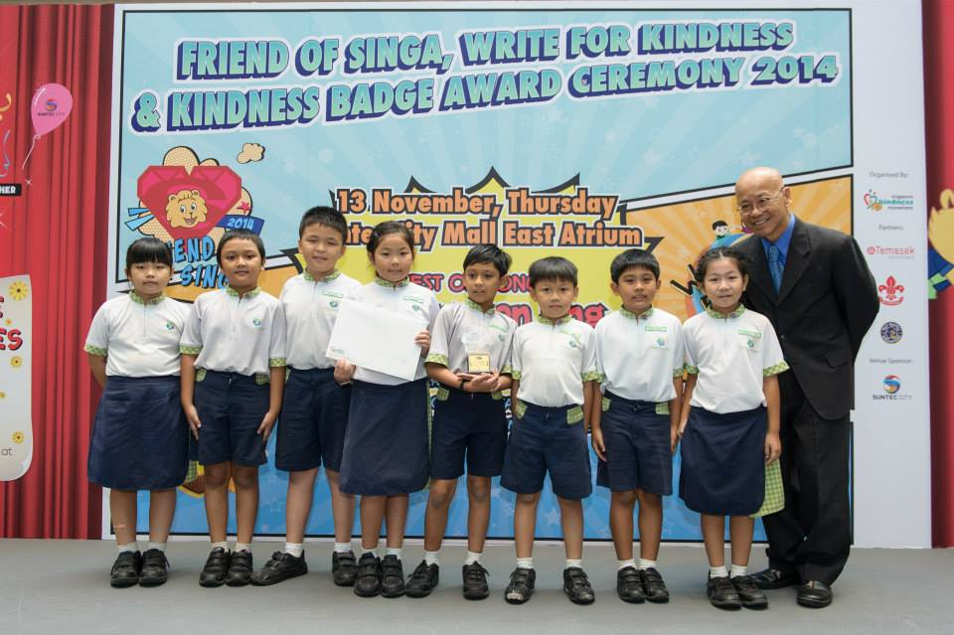
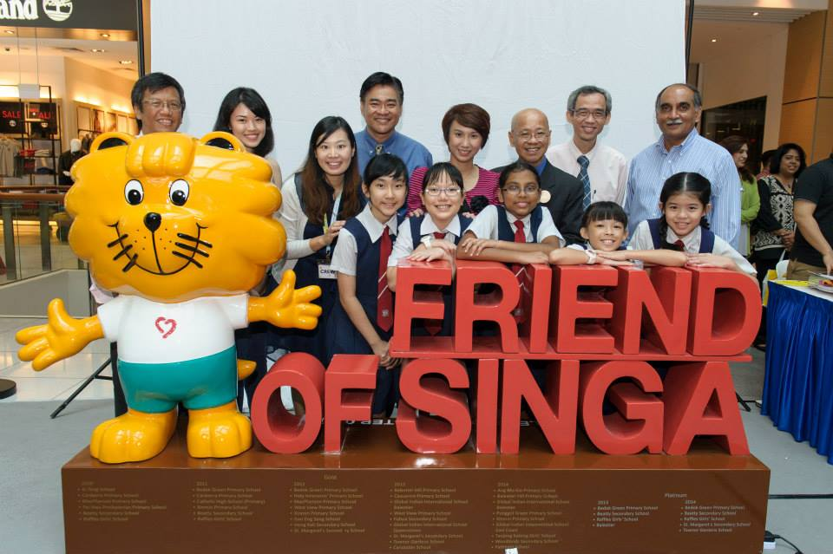
- THE FRIEND OF SINGA AWARD CEREMONY

The FOS Award Ceremony will be held on 13 November 2015, Friday.
All FOS students and teacher in charge are invited to attend the function. During the Award Ceremony, trophies will be given to representatives of the groups.
More details of the FOS Award Ceremony will be made available to participating schools closer to the ceremony date.
- FRIEND OF SINGA TIMELINE
Kindly adhere to the deadlines stated. Teams that fail to do so will be penalised.
DATE | TO-DO
30 January (Friday), 6pm | Deadline for Registration
6, 9-10 February | Workshops
25 March (Wednesday) | Submit Proposal
April to August | Execute Project and Write Report
26 August (Tuesday)  28 August (Friday), 5.30 pm | Mail out Report  Final Report to reach SKM
13 November, Friday | Attend Award Ceremony

Annex A
Friend of Singa 2015 Report Template

Here is the template for the FOS report. With font size 12, 1.5 line spacing and in no more than 5000 words (excluding part a, b, appendices & bibliography), please make the report clear and concise. Kindly adhere to the requirements as reports that fail to do so will be penalised.

- Executive Summary
Project Title:
School:
Teacher-in-charge:
Email Address:
Contact Number:
Nominated Team Members’s Full Names (As in NRIC):
1)
2)
3)
4)
5)
6)
7)
8)

(Please ensure that team member’s FULL NAMES are spelled correctly.
Replacement of the certificate/ trophy may result in delay of the collection. Any additional costs arising from the replacement of trophy or certificate will be borne by the school.)

Summary of Project in not more than 250 words (Describe/Explain type of gracious problem(s) identified in the school, key components of project):

- Summary of previous project in not more than 150 words (if school has participated before)
  - What was done in the previous project
  - Lessons learnt
  - State whether current project builds on the previous one, or is a recreation of it

Report format

- Objective of project items
- What the FOS ambassadors would like to achieve or see happening
- Why each of the project items are relevant to the problem

- Target audience
- Who the project items are catered for
- Target size
- Reason why this audience was chosen

- Details of project items
- What the project items are
- What each of the project item is about
- How each project item contributes to the whole point/Where each project item stands in the big picture
- Other information about project items

- Execution process
- Process to get the project items done
- How the project items were eventually carried out
- Possible areas of improvement/further development

- Conclusion/Evaluation/Limitations (in not more than 1 page)
- Level of success
- Future recommendations

- Appendices
- CD of photos, clearly labelled with school name
- Video, if any
- Pre & Post survey data
- Interviews with students/teachers, if any
- Students’ reflection about their learning experiences (e.g. journal logs)
- Referrals from school mates/teachers
- Detailed Claim form (Annex B & C) & Original Receipts (receipts to be pasted on paper + Photocopy of original receipts with school stamps)

- Bibliography (if any)

ANNEX B
Friend of Singa 2015- Claim Form
PARTICULARS FOR PAYMENT
Bank name & code:
Name of account holder:
Address of account holder:
Contact number:
PAYMENT MODE : CHEQUE (All reimbursements will be paid via cheque)
Cheque Payable to:
_______________________________________________________________
DECLARATION BY TEACHER-IN-CHARGE
I hereby certify that the information given is to the best of my knowledge and I agree to abide by all the terms and conditions on the award of Friend of Singa fund. I understand that the application will be decided at the sole discretion of SKM, and that its decision is final. SKM shall reserve the right to review, reduce, suspend, terminate or withdraw the assistance in accordance with the stated terms and conditions. Any failure or delay by SKM to exercise any of its rights or powers to claim a breach of the terms and conditions shall not prevent SKM from doing so at any time.
Name:  Designation:  School Name: |  | Tel No/DID:  Fax No:  Email:
_____________________________  Signature & Date |  | ______________________________  Official School Stamp
Before you sign the form and send it to us, please check the following:
- Have you filled in every section in the form?
- Has the form been endorsed by the teacher-in-charge & school?
- Have you enclosed ANNEX C + Original receipts?
- If your project/event is an Arts production, please include the synopsis/script
Friend of Singa 2015- Funding from SKM
ANNEX C
SCHOOL:
ADDRESS:
TEACHER-IN-CHARGE:
CONTACT NUMBER:
No. | ITEMS | PURPOSE | AMOUNT PAID ($)
1 | Eg: Vanguard Paper (10 pieces) | Poster to be placed in school canteen | 5.00
2 | Eg. Ice Cream Sticks (10 pieces) | For students to pass to their peers when they received a kind deed | 10.00
__________
Total: 15.00

PROJECT PROPOSAL FORM

FRIEND OF SINGA PROJECTS

To qualify for the Friend of Singa (FOS) 2014, students must complete a group project related to kindness and graciousness in their school community. To help kick start the projects, the Singapore Kindness Movement (SKM) will be funding up to $150 per project. Funds will be released to the schools after the project is completed and SKM receives the project report.

- Please note that the funds should not be used for purchasing items used for fundraising. Should there be fundraising, the collected funds should be used to offset the expenses incurred for the project. Also, not more than 20% of the funds should go into buying gifts or prizes for students.

WHAT IS THE PROCESS?

- The project must focus on aspects of kindness and graciousness in the school community. Students may consider:
- Raising the awareness of the benefits of having a kind and gracious school
- Celebrating (recognizing) the kindness of classmates or teachers
- Inspiring schoolmates and staff to practice kindness and graciousness in schools
- Highlighting the social graces that are found lacking and effecting positive change in schools
- Creating an impact in the school to bring about a more positive behavioural change

- Projects related to the larger community such as beach clean-ups, visiting an old folks’ home and donations to a charity organisation will not be considered for this award.

- Teams must submit the project proposal form by hand or mail by 25 March 2015, Wednesday, 6pm to qualify for FOS. Proposals may be submitted earlier.

- Application has to be submitted with a Project Proposal and Budget Statement.

- The Singapore Kindness Movement reserves the right to reject project proposals and reports which are not related to promoting kindness and graciousness in the school community.

- Please mail the completed form to:

Attn: Ms Faith Lee
Singapore Kindness Movement
140 Hill Street #05-01 Old Hill Street Police Station, Singapore 179369

Proposal form template
PARTICULARS OF PROJECT TEAM
Name of School:

Address of school:

Name of teacher-in-charge:
Email address:
Tel No: | Fax No:
PROJECT DESCRIPTION
Title of project:

Date (s) of project: |  | Estimated number of participants:  (excluding Project Team)
Other partners / sponsors (if any):

Description of Project
(You may attach a separate sheet if there is insufficient space)

ESTIMATED EXPENDITURE AND PROJECTED INCOME
Please provide a detailed breakdown for each budget item. If the project consists of a series of activities, please use separate sheets for each activity and give the overall surplus or deficit for the entire project.

Estimated Expenditure (e.g. venue rental, setup, publicity etc) | Amount ($)
TOTAL EXPENDITURE (A) | $
Projected Income  (e.g. other sponsorships, donations, ticket sales etc) | Amount ($)
TOTAL INCOME (B) | $
SURPLUS / DEFICIT (B) – (A) | $

